Jana Vikasa Social Service Society
Annual Report 2018-2019
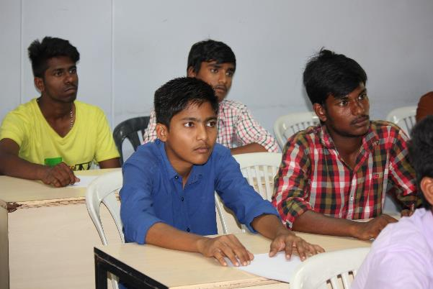

Presented to
General Body Members
30 June, 2019

Jana Vikasa Social Service Society
H.No. 1-1-772, Siddarthanagar, NIT Post, Warangal - 506 004
Jana Vikasa Social Service Society
Profile

Name of the organization : Jana Vikasa Social Service Society
Address : Jana Vikasa SSS
1-1-772 Sidharthanagar, Kazipet,
Warangal, 506-004, A.P. India.
Type of organization : Voluntary, secular, non-profit, non-government
Registered on : June 17, 1997
Registration number : 2881 of 1997
Pan number : AAA TJ 4879Q
FCRA number : 010360066 (May 28, 1999)
Registration act : Andhra Pradesh (Telangana region) Public Societies
ACT 1 of 1350 Fasli
Aim of the society : Socio - economic development of the rural poor
Area of operation : Telangana and Andhra Pradesh, India
Sectors : Community development, Education and Humanitarian
Donors : SOPAR - Canada and local donors
Bank and account no : 14022 Andhra Bank, Kazipet, Warangal, A.P.

Executive Body Members
President : S. Lourdhu Marreddy S/o late S. Chinnapa Reddy
Vice President : B. Pratap S/o late B. Marreddy
Secretary : G. Rama W/o Lakshma R.
Joint Secretary : T. Mariamma D/o late Joji Reddy
Treasurer : K. Shobha W/o. K. Joji R.
Founder -Honorary member : Bala Theresa Gingras
Honorary member : Marc Reddy Gingras

Jana Vikasa Social Service Society
Annual General Body Meeting
June 30, 2019

AGENDA

- Welcome
- Agenda reading and approval
- Presentation and approval of minutes of July 7, 2018 Annual General Body meeting
- Points arising from the minutes
- President’s message
- Presentation and approval of Jana Vikasa Annual Report 2018-2019
- Presentation and approval of Financial Audit Report 2018-2019
- Appointment of the Auditor for the fiscal year 2019-2020
- Elections
- Budget for 2019-2020 and approval
- Varia
- Vote of thanks and closing

Jana Vikasa Social Service Society
Minutes of the Annul General Body Meeting Held on July 7, 2018

S.No | Members | Designation | Present | Absent
1 | S. Lourdhu Marreddy | President | 1
2 | B. Pratap Reddy | Vice President |  | 1
3 | G. Rama | Secretary |  | 1
4 | T. Mariamma | Joint Secretary |  | 1
5 | K. Shobha | Treasurer | 1
6 | Y. Vasantha | Member | 1
7 | S. Sunitha | Member | 1
8 | S. Shoury Reddy | Member | 1
9 | G. Bala Thersa | Member | 1
10 | S. Anki Reddy | Member |  | 1

S.No | Members | Designation | Present | Absent
1 | Marc R. Gingras | Honorary Member |  | 1
2 | Bala Theresa Gingra | Founder& Honorary Member | 1
3 | A. Pushpa | Ex. officio | 1

# | Special Invitees
1 | D. Latha - Volunteer
2 | E. Vasantha - Volunteer
3 | Radhika - Volunteer
4 | Ranjeeth - Special invitee
5 | Amulya - Special invitee
6 | Sushmitha – From audit office
7 | Deepika –From audit office

- Opening Remarks
The meeting began at 11.15 am at Bala Vikasa PDTC, Fatima Nagar. The president welcomed all the members and extended a special welcome to Bala Theresa Gingras, Founder of Jana Vikasa SSS. He also welcomed all special invitees.

- Approval of the agenda
President presented the agenda. No additional points were added, and the agenda was approved unanimously as proposed by Y.Vasantha and seconded by S.Sunitha

- Presentation and approval of the minutes of AGM – 2018

In the absence of Secretary G. Rama, S.Sunitha presented the minutes. Questions were raised if the quarterly vouching verification is done or not. Answer is positive. Minutes were proposed by K.Shobha and seconded by G. Bala Theresa.
- Message from the president

The president expressed his happiness at the fact that Jana Vikasa is reaching the poor through different education and humanitarian programmes. He acknowledged and appreciated SOPAR’s extended support. He thanked the partner institutions for taking care of the humanitarian program. He appreciated the dedicated services of Pushpa the only staff and Shobha the treasurer for their dedicated services. He also thanked Bala Vikasa staff and JV executive members and above all, gave special thanks to the founder Bala Theresa for her tireless support to Jana Vikasa.

- Annual report

Jana Vikasa Director Ms. A.Pushpa, Treasurer Ms.Shobha, BV widow Empowerment program staff Radhika presented in detail the Annual report of Jana Vikasa activities for the year 2017-18. All the members were pleased to see the numerous achievements of the organization and congratulated all concerned.

Founder Bala Gingras said Jana Vikasa helped for 17 projects in the financial year. Jana Vikasa organized a meeting to all its partner organizations to discuss the impact of the help and also to review the process for application and reporting. Mrs. Gingras also appreciated the project holders in a special way for effective timely implementation & correspondence.

The Annual Report 2017-18 was unanimously approved as proposed by S. Shoury Reddy and seconded by Y. Vasantha.

Ranjith and Amulya shared their experience as beneficiaries of Jana Vikasa and expressed their gratitude.

- Audit report

In the absence of the auditor Mr. Vamshidhar from SCV Associates Auditing firm, Mrs. Sushmitha the intern from their firm presented the organization’s audit report for the year 2017-18.
The Audit Report and statement of accounts as presented for the year 2017-18 were unanimously approved as proposed by S.Sunitha and seconded by Y. Vasantha.

- Appointment of the Auditor for the year 2018-19

The Treasurer K. Shobha expressed satisfaction with the services given by SVS associates Auditing Firm and recommended to continue for the coming year 2018-19.
Upon the proposal of Y. Vasantha, seconded by T. Mariamma, Board approved unanimously agreed to appoint SCV & associates of Charted Accountancy Firm to audit the accounts for Jana Vikasa for the year 2018-19.
- Approval of the Annual Budget

The treasurer K.Shobha presented the consolidated budget of local and foreign funds for the year 2018-19.

Mrs. Gingras said that the regular donor organization-Call of the Poor that helps SOPAR for humanitarian programs is reducing its donation considerably from this year on. The main reason is its president died and his daughter that took over the responsibility also is sick and therefore we have to accept this fact and see how to plan the future activities that will be fitting to the aims and objectives of the organization.

Board discussed at length and concluded that 1) to help our partner institutions with Humanitarian projects as much as we receive such support from donors and 2) to help experienced partner institutions with development projects with the interest generated from Corpus Fund.

Proposed by S.Sunitha and seconded by G. Bala Theresa it is accepted unanimously that to help partners with Humanitarian projects with the donations received from donors for such programs and to help Bala Vikasa or experienced partners for their development programs with the interest coming from CF.

With the above recommendations it is proposed by S.Sunitha and seconded Bala Theresa, the budget presented for the year 2018-19 was unanimously approved.

- Elections

Mr. Anki Reddy and Anasuya, S. Shoury Reddy, G. Bala Theresa and Vasantha have requested to withdraw from the General body. This is proposed and unanimously approved.

- Varia
No point is in Varia.

- Closing

The meeting is closed at 1.30 pm. The president thanked all the members and guests for their presence and support. He expressed gratitude to SOPAR Board and Call of the Poor for their generous support. He thanked in a special way Mrs. Gingras for her continuous support.

S. Lourdhu Marreddy G. Rama
President Secretary

MESSAGE FROM THE PRESIDENT

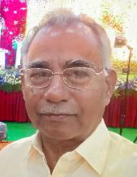
This year marks special in the history of Jana Vikasa. We have revised our aims and objectives accordingly, planned to take up development programs along with humanitarian as we did for few years at the beginning of Jana Vikasa.
As always, we select credible and capable organizations as our partners to take up our programs.
This year, we have received an interesting proposal from Bala Vikasa for Women Empowerment Program. We have studied, analysed and accepted. This program is multi angled, helps thousands of rural poor women and dis-advantaged Widows, empowering them socially, economically, psychologically, intellectually and ethically. It aims to bring them into mainstream, ameliorating their quality of life, putting accent on equality, human rights, bringing justice and peace. It helps in changing the attitudes and bringing positive change in the society.
Bala Vikasa is well-known, experienced, credible and capable organization. Joining hands with it is an added value to Jana Vikasa. Myself and some of the Board members have visited some of its activities and assisted its capacity building trainings and thus confident that our funds are put into best use according to our aims and objectives and bring best and lasting positive results.
We also continue our help to those that can not help themselves through Humanitarian projects.
I take this opportunity to thank our donor organizations SOPAR and Call of the Poor for their trust in us. I thank also, Ms. A. Pushpa, the Jana Vikasa Program Officer and Ms. K. Shobha the Treasurer for their dedicated services in taking care of our programs and finances.
I would like to express my appreciation towards all our Board members and volunteers for their input in the organization. Most importantly I would like to thank our founder, Bala Theresa Gingras for standing as a model to us, inspiring, stimulating, instilling values in us and supporting us in carrying our mission.

S. Lourdhu Marreddy
President

Activity Report 2018-19

Jana Vikasa as always try to find ways to help more and more deserving people through innovative methods. Accordingly, this year, we have taken a big step and joined hands with Bala Vikasa in order to help thousands of deserving rural poor villagers especially women, widows and children. In addition, helped 1166 people mainly children with 6 humanitarian projects.

1. Development Program-Women Empowerment
We have received a comprehensive, multi-angled proposal from Bala Vikasa in December 2018 for Women Empowerment program that reaches more than 50000 women, thousands of Widows and hundreds of children. Jana Vikasa analysed and accepted to help as Bala Vikasa has many years of experience and proven record in bringing excellent results. Bala Vikasa is credible and transparent, open for anybody to visit. Program is long term, thus continues in 2019-20.

2. Humanitarian Programs
2.1. Help Children with HIV-AIDS and Mentally disabled
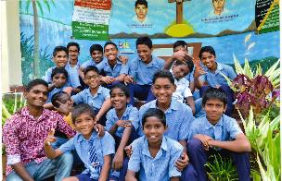
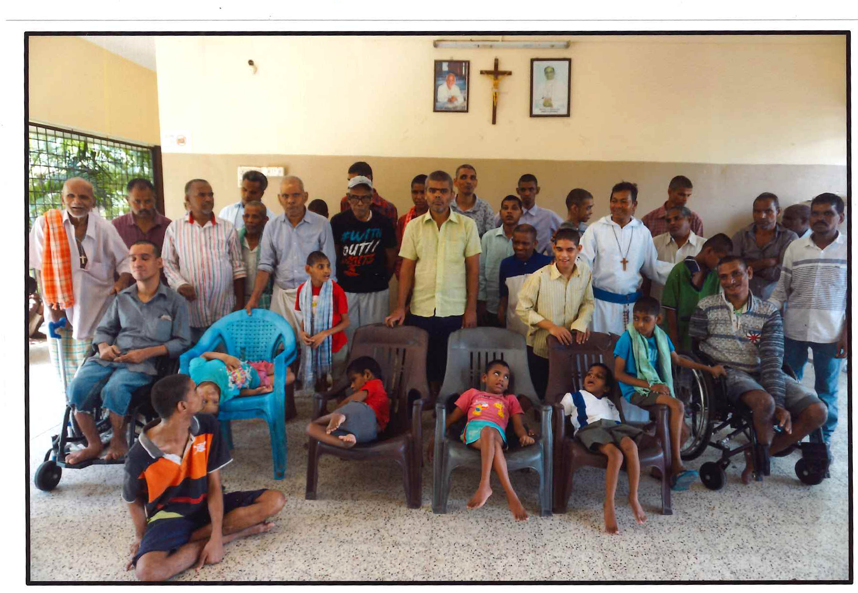Jana Vikasa helped Brothers-Fathers of Our partner institution “Missionaries of the Poor” in Fathimanagar. They are taking care of 30 children that are suffering with HIV-AIDS in the house called “Divine Mercy home”. The children are provided nutritious food, medicines, and cloths and are put in nearby schools and helped in their studies. They are given brotherly love and care.
Same way the brothers also are taking care of 115 people that are mentally disabled in the house called “House of Joy”. Brothers show love and give dedicated services, feed them, cloth them and take care of them in every way.

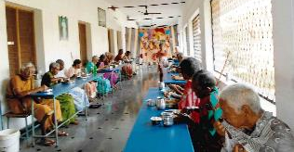
2.2. Help the Aged
Jana vikasa helped Catechist Sisters of St. Anne, and Sisters of Nirmala Dasi to help the deserving 107 poor Aged people. They are fed, clothed and taken care.
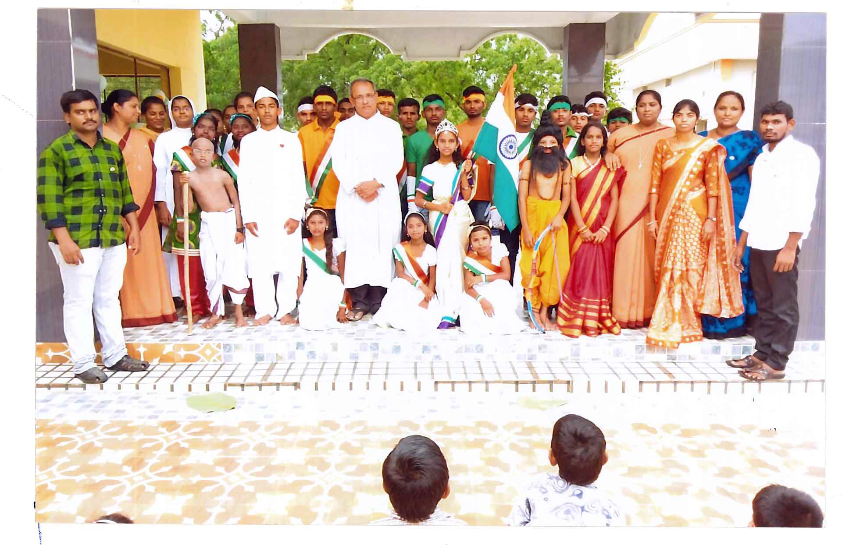2.3. Children with special needs
Jana Vikasa helped Sisters of St. Anne to help 75 children that were intellectually challenged staying at St. Ann’s Ushodaya School, Guntur. Sisters provided food, clothes and medicine besides giving love and care.
2.4. Help with cloths
Jana Vikasa helped some deserving 839 people with cloths.
3. Closing
Jana Vikasa continues helping people through well-selected partner organizations. We appreciate the dedicated services of all our partner organizations and the people that are working there. We wish all the best to all the beneficiaries.
